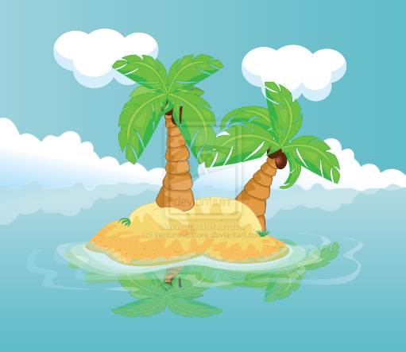

Always; who and what I always want with me

This technique helps gain an insight into a child’s experience of who and what is important to them.

Children might want to draw a bridge between Always and Sometimes. Or maybe they will have a boat!

This activity is adaptable and it is the concept that needs to be used

Extra protection might be wanted around the Maybe Never Island – sharks maybe, or jagged rocks?

Maybe you will be able to explore what would need to change in order for the people or things on this bottom island to be able to move to one of the other islands.

Sometimes; who and what I sometimes want with me

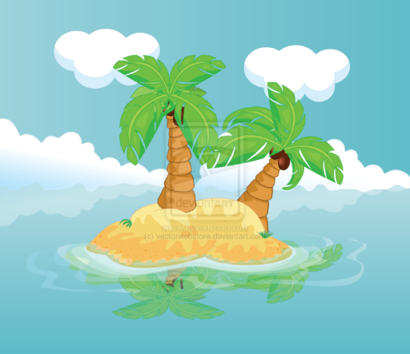

Never; who and what I never want with me

