**Information about Joining the Dynamic Support Register**

This easy read leaflet is about the Dynamic Support Register and deciding if you give your consent to join it.

This easy read leaflet is for people with learning disabilities and or Autism who might be at risk of going into a specialist hospital or placement because



of a mental health problem or behaviour which is seen as challenging.



It is also for family, carers and other people who can support you to understand what the register is about and if it’s right for you.



Dynamic Support Register

The Dynamic Support Register is about helping you get the right care and treatment in your community whenever possible, by working with you and those who support you.

Most people with mental health problems or challenging behaviour can live well in the community and may never need to go into a specialist hospital for assessment or treatment or live in a residential setting.

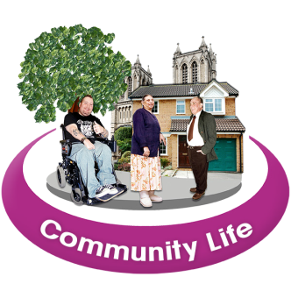

But if you do experience a difficult time and your current care is not meeting your needs, you and people who support you will need to think about what extra support you will need.



Often this support can be given locally in the community but sometimes people need to go into a specialist hospital to get better. This form is about making sure you and your child are included in decisions.



# What is the Dynamic Support Register?

The register is about being able to respond quickly if someone’s care isn’t meeting their needs and what changes can be made to help with this and to stop people reaching crisis point. It helps services work with you to decide what support you may need.



**This leaflet gives you information so you can decide if you want your details to be on the register.**



Specialist hospitals and placements are often a long way from your family and friends. Sometimes you may need to spend a long time in hospital.



Dynamic Support Register

The register is one of the local changes that is happening to help more people get the support they need to stay in the community.

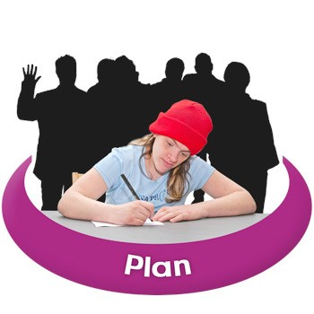

# What are the good things about joining the register?

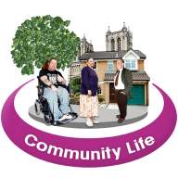

The register is about helping people get the right support as fast as possible, if they ever need it.

This is because services will know what extra help and support you might need and can plan their support around this. You will be involved in planning your care and support.

# What if I don’t want to join?



You will still get support if you need it, but if services do not already know about you, this may affect how much support you get at the time and how long this support may take to arrange.



This is because services need more time to plan urgent care.

# Is it right for me?

It is a good idea to talk to people who understand you support needs. They will help you understand what the register is about and help you decide if it’s right for you.

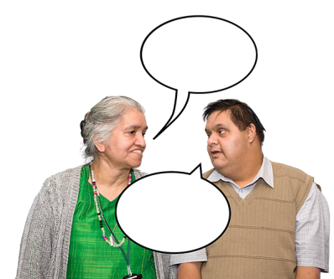

# What happens if I am on the register?

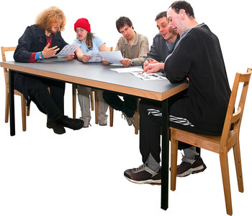

If you are on the register this means the people who pay for you care can work together and more quickly to think about the support they can offer should your needs increase.

If you are at risk of going into hospital, we will invite you to have a Care (Education) and Treatment Review, called a Community CETR. This should happen before any decisions are made about whether hospital care is right for your child.

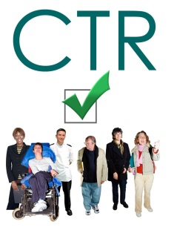

This looks at why you might need to go into hospital and whether extra support can be given in the community instead. It helps you and your care team plan for the support you need in the place you need it.



# How your care co-ordinator can

**help**



You can talk to your care co-ordinator you aren’t sure about anything, or if you want to change your mind about being on the register. You can add your care co-ordinator’s details in the table below.

|  |  |  |
| --- | --- | --- |
|  | **The care**  **co-ordinator is:** |  |
| Image | **Mobile phone number:** |  |
| Image | **Office telephone number:** |  |

# What is consent and why do we

**need it?**

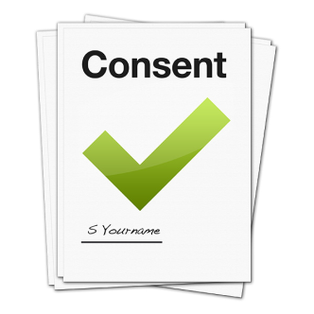

Consent is about understanding the facts so you can decide what’s right for. A child or young person’s details only go on the register if parental consent has been given.

# About consent:



* you can change your mind at any time
* you will receive a copy of the consent form
* you can find out what information is being held about your child

# What will happen to my information?

Your personal information will be kept in a safe place by your NHS ICB (NHS Integrated Care Board) and it will only be shared with you and people who provide your care now or in the future.



Anonymous information from the register is safely shared with other parts of the NHS. This information does not include individual names or any other personal information which could identify anyone.



Dynamic Support Register

This information helps health and social care teams to understand what difference the register is making in people’s lives and to provide the right kind of services.

# What sort of information will the register include?



The information will depend on your care and support needs. But usually it will include information about:

* the care and treatment you are receiving
* you health, including mental health
  + any health and care plans that have been developed for you
  + where you live and who you live with
  + things that can make you upset and what helps you feel well
  + It will also include your name and date of birth



* + anything that people involved in providing your care and support should know to keep you safe.

# Next steps – giving your consent!



Have you understood the information in this document?

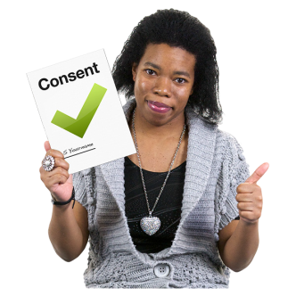

If so, you are ready to fill in the Consent Form to say whether or not you give your consent.



Your care co-ordinator or someone involved in supporting you and can help you fill it in.

This document was adapted from The Friendly Information Company for NHS England. September 2015.



Graphics by Photosymbols.