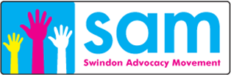
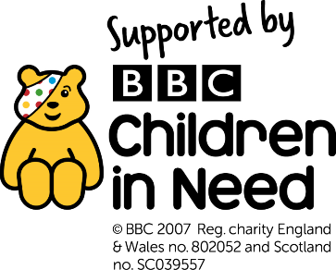

The Indy Project
Swindon Advocacy Movement is excited to announce the launch of a brand new children and young people’s advocacy service called The Indy Project. Funded by Children in Need this three-year project aims to enable children and young people aged 10-18yrs to reach personal independence goals. Children and young people who have a disability or SEN will be able to refer themselves to the project or ask parents, carers, teachers or professionals to make the referral for them.
The Indy Project will be led by a children’s advocate supported by an enabler and the Swindon Advocacy Movement children and family service. Ideas for advocacy intervention include; learning a bus route, joining a club, learning a new skill, finding a work experience placement. However, all goals will be chosen by the young person themselves with ten-weeks of 1:1 intervention, followed by the option of moving into a small group to practice the new skill. Weekly advocacy sessions will also enable the children/young person’s achievements to be recorded and celebrated, resulting in a useful document that they can use in the future.
If you know a child or young person that may benefit from The Indy Project please put them in touch with Adele at SAM or ask for a referral form yourself.
Adele can be contacted at SAM on 07500665686 or adelelawrence@swindonadvocacy.org.uk and is happy to answer any of your questions any referral’s need to be sent to secure@swindonadvocay.co.uk
Registered charity 1070038
Limited company number 3388017

